Pan blisko jest

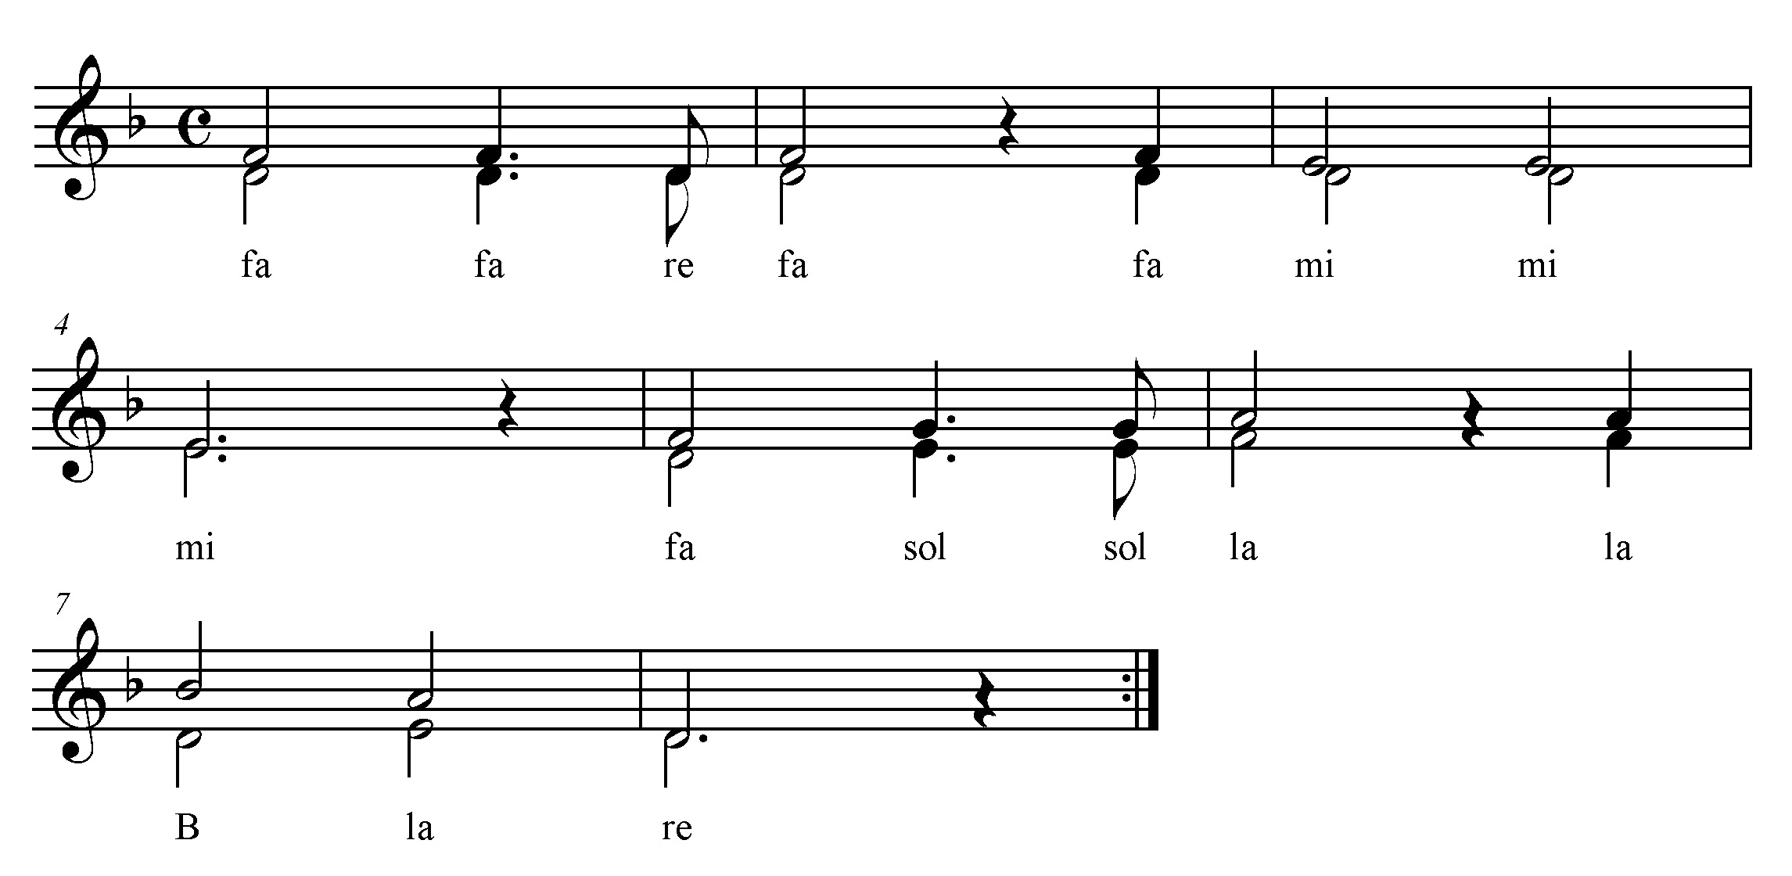

Pan blisko jest,
oczekuj Go.
Pan blisko jest,
w Nim serca moc.

Wait for the Lord,
whose day is near.
Wait for the Lord:
Keep watch, take heart!

